Long Buckby Junior School Covid-19 Risk Assessment for Schools Updated November 2020
To be reviewed by November 1st 2021
The technical name of the virus that causes COVID-19 is severe acute respiratory syndrome coronavirus 2, abbreviated as SARS-CoV-2
Whilst the Covid-19 virus can cause serious illness, especially for vulnerable adults with underlying health conditions evidence suggests that for the majority (particularly children and young people) they will experience a mild to moderate illness.
Whilst this is a complex and changing situation, there is enough known about the epidemiology of Covid-19 to provide a risk based approach to support staff in their roles.
The assessment below has been developed based on the following principles:
- That we will act together to ensure the safety and reassurance of all staff, children & young people.
- PPE will be recommended according to evidence of efficacy and assessment of clinical risk.
- All efforts will be made to secure a reliable and adequate supply of suitable PPE.
- PPE does not negate the need for social distancing and hand and respiratory hygiene.
- Having entered a period of sustained, community transmission, all staff and pupils are approached as potentially carrying Covid-19.

Potential Hazard | Risk | Who might be harmed? | Minimum control measures to reduce risks to an acceptable level
Covid-19 | Staff not having appropriate knowledge on virus, transmission and risk leading to increased transmission of covid-19 | Employee, and visitors | - All staff to keep themselves updated and follow the latest Government and national Public Health England/NHS guidelines via https://www.gov.uk/coronavirus  - https://www.nhs.uk/conditions/coronavirus-covid-19/  - Updates to be shared with staff through internal email system as appropriate.  - Visitors discouraged from coming into the school building.  - Staff informed on the impact of room humidity on the virus and ventilation.
Covid-19 | Contagious people coming into school leading to increased transmission of covid-19 | Employee, visitors, agency staff, member of the public, Pupils | - To help ensure that the risk of virus spread is as low as possible, the school to tell staff and potential visitors, including customers and contractors, not to enter the school if they are displaying any symptoms of coronavirus (COVID-19) or if they should be self-isolating after testing positive within at least the last 10 days.  - Anyone showing the symptoms (new continuous cough and/or a high temperature, loss of sense of smell or taste) should not come to work, get tested for Covid 19 and follow the relevant government protocols at home and before coming back to work, this will last at least 10 days.  - Staff and regular visitors are using Lateral Flow Devices to test for Covid 19 twice a week.
Transmission of Covid-19 via arrival at school | Increased transmission of virus on arrival at the school premises | Employee, visitors, agency staff, member of the public Pupils. | - Hand washing on arrival to be enforced for all adults and children.  - No visitor to be unaccompanied if they need to go beyond the office ‘air-lock’.
Poor hand & respiratory hygiene | Poor hand & respiratory hygiene leading to increased transmission of covid-19 | Employee, visitors, agency staff, member of the public, Pupils | - Follow Hand Washing protocol at appendix 1 below https://www.who.int/gpsc/clean_hands_protection/en/  - Soap and water, and regular hand washing for at least 20 seconds, is the best way of staying safe. Hand washing with soap employs mechanical action that loosens bacteria and viruses from the skin, rinsing them into the drain. This should be done when children come into school in the morning and before they eat. Drying hands afterwards makes the skin less hospitable to the virus.  - Staff, visitors and pupils should be reminded to wash their hands for 20 seconds and more frequently than normal, including on arrival at the setting, before and after eating, and after sneezing or coughing.  - Coughs and sneezes to be caught in tissues. Bins for tissues should be emptied throughout the day – cleaner on duty all day, throughout the day. Tissues are available in the classrooms.  - Some children and young people with special educational needs and disabilities may require additional support in following public health advice, or may find frequent hand washing distressing. Staff should know where this is likely to be the case, and how they can best support individual children and young people.
Surfaces contaminated with Covid-19 | Increased transmission of covid-19 via surface – face contact | Employee, visitors, agency staff, member of the public, pupils | - Regular points of contact such as door handles, push plates, code pads and WC levers should be cleaned regularly unless it is already known (with certainty) that the building has not been in use for 48hrs – cleaner on duty during the morning and after school cleaning contact points.  - Shared areas, classrooms and furniture are cleaned regularly on a rota by a cleaner during the morning and at the end of each day.
Intimate care and minimising the risk of Covid-19 | Intimate care procedures leading to increased transmission of covid-19 | Employee, visitors, agency staff, member of the public, pupils | - The virus that causes COVID-19 is mainly transmitted through droplets generated when an infected person coughs, sneezes or speaks. These droplets are too heavy to hang in the air. They quickly fall on floors or surfaces. The advice for schools, colleges and childcare settings is to follow steps on social distancing, hand washing and other hygiene measures, and cleaning of surfaces. A cleaner will be in school throughout the day.  - If you are not providing intimate care to someone, PPE is not needed.  - Some children, and young people with special educational needs, may be unable to follow social distancing guidelines, or require personal care support. In these circumstances, staff need to increase their level of self-protection, such as minimising close contact (where appropriate), cleaning frequently touched surfaces, and carrying out more frequent handwashing. School staff should continue to use the PPE that they have always used (such as an apron and gloves) when undertaking more intimate care with pupils.  - Child with tracheostomy to have individual care plan, to not sit next to any other child, 1:1 TA to wear a face mask. If suctioning or completing a full change full PPE must be worn.  - School follows the health guidance provided.  - Staff have been fit tested to ensure they have access to the correct PPE in order to meet the needs of the child.  Protocol for the use of PPE (Based upon Public Health England Guidelines).  - In circumstances where staff feel PPE is appropriate following the principles above careful judgement should be used to consider likely risk and also any impact of behaviour the child/young person may demonstrate as a result of PPE being worn. The wearing of PPE unless carefully removed in itself can add increased risk therefore it is expected that PPE in educational settings will only be required for momentary use and not for long period of time. Visors have been chosen as they are easier to remove safely and the child can still see facial expressions of the adult tending to them and also hear them clearly.
   | Category | PPE Requirements | Educational Setting
  1 | Staff / Pupil interaction where distance of 1m can be maintained throughout. | Close adherence to hand (i) and respiratory hygiene protocols (ii).  No additional PPE required beyond what would usually be worn for any given task | The majority of school and childcare settings will fall into this category. For example Class Teacher and Classroom assistants working within a classroom environment where social distancing can be adhered to.
  2 | Staff / pupil interaction where momentary (iii) physical contact is required or cannot maintain 1m distance. | Close adherence to hand and respiratory hygiene protocols.  Surgical facemask to be worn by member of staff. Sessional (iv) use is adequate in these circumstances. | In some childcare and school settings where intimate care is required it may be necessary to wear a visor when undertaking certain tasks (e.g. administration of medication where it cannot be self medicated, or when administering first aid, self-administration is not possible e.g. child places their own plaster on a cut / laceration The visors will be named and used only by first aid staff along with gloves and disposable aprons.
  3 | Prolonged/intimate (v) physical contact is required between member of staff and Pupil. | Close adherence to hand and respiratory hygiene protocols.  PPE required - Disposable gloves, disposable apron, sessional surgical facemask, (include eye protection if client is coughing or sneezing). Donning and doffing according to standard protocols (vi) and disposing of clinical waste appropriately (vii). | Anyone who is symptomatic should not be in a childcare or school setting. However, if required to undertake intimate care with a child or young person then category 3 PPE will apply e.g. If a child requires intimate care when administering first aid as a result of serious injury. If that child were coughing or spitting, this should include eye protection.
When essential travel in a vehicle is required | Sharing a vehicle where social distancing is not possible leading to increased transmission of covid-19 | Drivers, Pupils and accompanying staff | - When having to travel for business related please only travel when this is essential.  - When using a private vehicle to make a journey that is essential, cars should only be shared by members of the same household. Those who normally share a car with people who are not members of their own household for a journey that is essential, e.g. getting to work, should consider alternatives such as walking, cycling and public transport where you maintain a distance of 1 metre + from others. If this is unavoidable a mask should be worn and the windows should remain open in the car to allow for ventilation.  - Where using a car is essential involving two or more people, it is recommended that two or more cars are used rather than staff travelling together in the same vehicle.  - Staff where possible should use their own vehicle  - Staff should not share a vehicle with a pupil unless it is as an absolute last resort. (e.g. Emergency response).
Increased lone working | Becoming injured when help is not at hand | Employees and contractors | - Many social distancing measures result in an increase in lone working, something that is usually minimised.  - If you are lone working it is important to follow lone working guidance and ensure a buddy system is implemented and you are in regular contact re your whereabouts.
Managing risk if an individual displays symptoms | Proximity to a person displaying covid-19 symptoms leading to increased transmission of covid-19 | Employee, pupils, agency staff, member of the public | - https://www.gov.uk/government/publications/guidance-to-educational-settings-about-covid-19/guidance-to-educational-settings-about-covid-19  - If someone becomes unwell and starts to display symptoms and starts to display with a new, continuous cough, loss of sense of smell, taste or a high temperature in an education setting they must be sent home and advised to follow the staying at home guidance.  - If an affected person is awaiting collection, they should be moved, if possible, to a room where they can be isolated – Sunshine Room. If they are a child, depending on the age of the child appropriate adult supervision may be required. Ideally, a window should be opened for ventilation. If it is not possible to isolate them, move them to an area which is at least 2 metres away from other people. The member of staff supervising the child should be in PPE.  - The isolation room should be cleaned and disinfected after the child has been collected from the school.  - If they need to go to the bathroom while waiting to be collected, they should use a separate bathroom if possible – disabled toilet. The bathroom should be cleaned and disinfected using standard cleaning products before being used by anyone else.
Deliveries and Maintenance on school sites | Increased number of people onsite leading to increased transmission of covid-19 |  | - Only essential repairs and maintenance work should be carried out  - Deliveries that need to be handled immediately should be collected wearing gloves and left 72 hours where possible before opening. If this isn’t possible, thorough hand washing will apply as normal and purchased goods need to be left for72 hours.  - Room used by outside contractor to cleaned and disinfected after use.  - Keep deliveries to a minimum with important items only.
Pregnant member of staff contracts Covid 19. | Potential risk to staff who are 28 weeks or more pregnant. | Employee | - Member of staff to work remotely using Google Classroom either from a room within school or from home.

Appendix 1: Clean hands protect against infection (WHO protocol)
Protect yourself
- Clean your hands regularly.
- Wash your hands with soap and water, and dry them thoroughly.
- Use alcohol-based handrub if you don’t have immediate access to soap and water.
How do I wash my hands properly? Washing your hands properly takes about as long as singing "Happy Birthday" twice, using the images below:
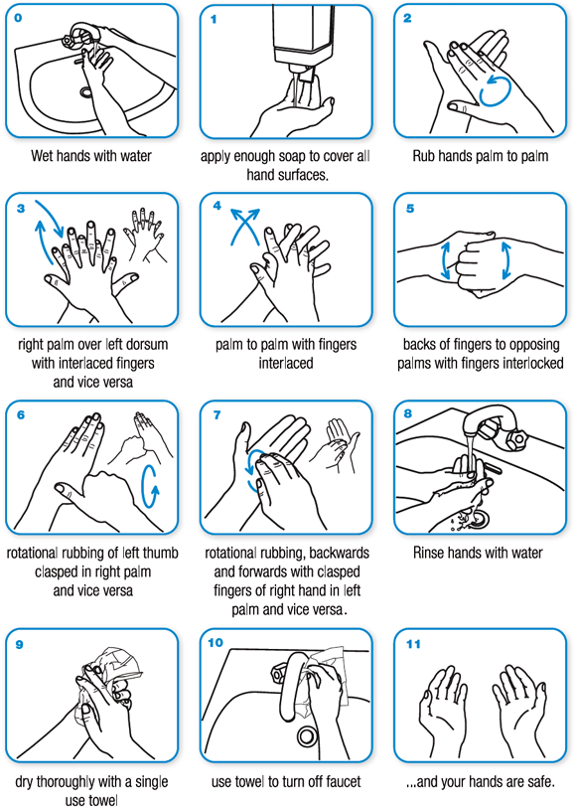

i.  Appendix 2 | Handwashing Protocol | Attached at appendix 1 above https://www.who.int/gpsc/clean_hands_protection/en/
ii | Respiratory hygiene protocol | This means covering your mouth and nose with your bent elbow or tissue when you cough or sneeze. Then dispose of the used tissue immediately. https://www.who.int/emergencies/diseases/novel-coronavirus2019/advice-for-public
iii | Momentary contact | Relates to ad hoc interventions that may create proximity to bodily fluid – e.g. a driver putting a seatbelt onto a client.
iv | Sessional use | Surgical facemask can be used multiple times and need not be disposed of until wet, damaged or uncomfortable. https://www.gov.uk/government/publications/wuhan-novel-coronavirusinfection-prevention-and-control/covid-19-personal-protective-equipmentppe#section-6
v | Intimate care | Is defined as a role which is personally supporting the client to bathe, wash, feed etc. where there may be close proximity to bodily fluids.
vi | Donning and doffing | Refers to the correct method by which PPE should be put on and taken off.. https://www.gov.uk/government/publications/covid-19-personalprotective-equipment-use-for-non-aerosol-generating-procedures  https://www.youtube.com/watch?v=-GncQ_ed-9w
vii | Disposal of PPE | PPE should be bagged and disposed of in a lidded bin followed by close adherence to hand washing protocol.
viii | Shielded person | Definition at appendix 3.
ix | Single use | Refers to disposal of PPE after each client interaction.
x | PHE Covid-19 IPC | https://www.gov.uk/government/publications/wuhan-novel-coronavirusinfection-prevention-and-control?utm_source=7c916e5e-b965-44d0-a304cf38d248abba&utm_medium=email&utm_campaign=govuknotifications&utm_content=immediate

Appendix 3
People falling into this extremely vulnerable group include:
1. Solid organ transplant recipients.
2. People with specific cancers:
- people with cancer who are undergoing active chemotherapy
- people with lung cancer who are undergoing radical radiotherapy
- people with cancers of the blood or bone marrow such as leukaemia, lymphoma or myeloma who are at any stage of treatment
- people having immunotherapy or other continuing antibody treatments for cancer • people having other targeted cancer treatments which can affect the immune system, such as protein kinase inhibitors or PARP inhibitors
- people who have had bone marrow or stem cell transplants in the last 6 months, or who are still taking immunosuppression drugs
3. People with severe respiratory conditions including all cystic fibrosis, severe asthma and severe COPD.
4. People with rare diseases and inborn errors of metabolism that significantly increase the risk of infections (such as SCID, homozygous sickle cell).
5. People on immunosuppression therapies sufficient to significantly increase risk of infection.
6. Women who are pregnant with significant heart disease, congenital or acquired.

NB: Patients should have received notification directly from the government and or their GP practice about whether they fall into this group and how to reduce their risk.

