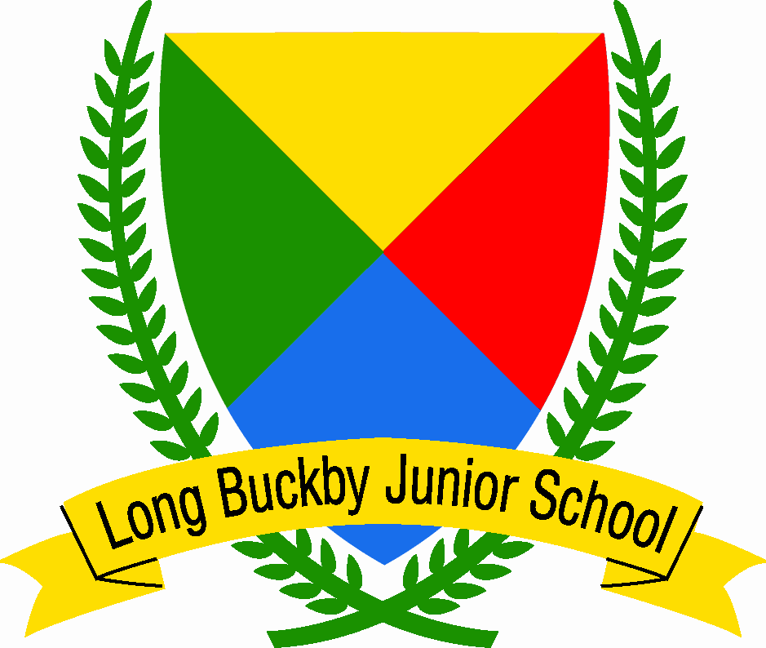

Policy | Behaviour and Relationships Policy
Date | September 2025
Review Date | September 2026

Long Buckby Junior School
Behaviour and Relationship Policy

This policy has been written with due regard to the responsibility of the school to adhere to the Public Sector Equality Duty of 2010 to:
  - Eliminate discrimination and other conduct that is prohibited by the act.
  - Advance equality of opportunity between people who share a protected characteristic and people who do not share it.
  - Foster good relations across all characteristics – between people who share a protected characteristic and people who do not share it.

Aims and Expectations
- It is a primary aim of our school that pupils, staff, governors, parents/guardians and visitors feel valued and respected, and that each person is treated fairly and well. The school Behaviour and Relationships Policy is therefore designed to support the way in which all members of the school can live and work together in a supportive way.
- To help children to grow in a safe and secure environment, and to become positive, responsible, resilient and increasingly independent members of the school community with a positive sense of self-esteem.
- To promote and praise good behaviour and positive relationships; and challenge inappropriate behaviour when it arises.
- Work with those children who need help in how to form positive relationships and understand how their behaviour can impact upon their ability to do this.
- To develop a level of self-discipline and acceptance of responsibility for themselves and their own actions within the children at the school.
- The school makes it clear that it will not tolerate inappropriate language, bullying, violence, racial /sexual harassment and sexual violence. There will be no toleration of any form of bullying including; racial, religious, cultural, SEN of any form related to medical, social, physical or mental conditions and sexual orientation.

Underlying Principle
At Long Buckby Junior School we use Emotion Coaching to instill high empathy and high guidance amongst children. The approach focuses on ‘connecting before correcting’ allowing staff to validate children’s feelings, teach emotional literacy and problem solve challenging behaviour. Staff use active listening and role modelling to Emotion Coach.

We are trained to use the five steps integral to Emotion Coaching:
- To be aware of a child’s responses
- To recognise emotional times as opportunities for intimacy and teaching
- To listen empathetically and validate a child’s feelings
- To help a child to verbally label emotions. This helps to soothe the nervous system and promote recovery rate. Staff will use words to reflect back a child’s emotions.
- To set limits while helping a child to problem-solve

Approaches to Developing the Skill of Positive Behaviour and Relationship Building
At Long Buckby Junior School we take a three-tiered approach to developing the skill of emotional regulation, positive behaviour and relationship building in the children.

Tier 1
Tier 1 is for those children who already show a high level of skill in managing their behaviour, feelings and who can also form positive relationships with both their peers and adults. These children will be able to follow the school’s reward and consequences system without the need for any intervention.

Tier 2
Tier 2 is for children who are struggling with managing their emotions, behaviour or struggle with forming appropriate relationships. These children may have:
- Exhibited a change in their behaviour;
- May have a diagnosed condition which necessitates a form of in-school intervention;
- May have had a change in personal circumstances which has affected their behaviour and ability to form and maintain positive relationships.
- May have been subject to a safeguarding concern.

Emotion Coaching underpins a range of interventions that will be used with these children operating at Tier 2. These could include:
- Meet and Greet
- Pre-learning in lessons
- Small group work with activities based around social skills programmes.
- Time out
- Time in
- Checking in with a named adult.

The intervention used would depend upon the individual needs of the child.

Tier 3
Tier 3 is for those children whose needs go beyond Tier 2 and need a more specialist intervention.

Tier 4
Tier 4 is for those children whose emotional and behaviour difficulties necessitate a referral to an outside agency for further advice or support, for example the School Attendance Support team at the local authority.

The school’s Sex and Relationship Policy contains more information about how the school works with children to teach them about positive relationships and keeping themselves safe.

Whole School Procedures
Whole School Rules
The basic premise of the school is that all children should adhere to and follow the agreed rules to ensure positive relationships within school. If a child chooses not to follow the rules then they should accept the consequences of their actions. The principle of Emotion Coaching emphasises the importance of setting limits for behaviour, ensuring children are aware of behaviours that are not accepted. Our school rules form these limits. These rules are:
- Be kind (to everyone, keep unkind words and thoughts to yourself).
- Show respect (to all people – adults, children and property).
- Be safe (keep yourself safe and do not endanger others).

At the beginning of each year the rules are discussed with the children and illustrated. These rules will be used consistently in order to make our school a happy and safe place.

Learning Behaviour During Lessons
A traffic light system is used in class based on the premise that every child has a ‘right to learn’ and ‘teachers have a right to teach.’

Well done!


You are making the right choices.

You are ready to learn.

First Warning

You need to consider your choices.


You need to ask for help.

You need to get ready to learn.

Second Warning

You need to consider your choices again.

You need to ask for help again.

You need to get ready to learn.

Consequences
Your name on the board
Ten minutes reflection time at break to catch up on work you have missed.
Final Warning

Your choices are not helping you to learn.

You need time to think about what has gone wrong.

Consequence
You will be taken to your allocated area.
You will reflect on your choices.
Get ready to learn before you return to class.

Whole School rewards System
- Children can earn House Points by working hard during lessons.
- Each week every teacher nominates two children for a Gold Award from their class and the child receives a certificate.
- The school holds a Celebration Assembly once a week which is run by the children. This is used to celebrate a whole range of in and out of school achievements.

Whole School Consequence System
- If a child consistently makes the incorrect choice – they have to take the consequences of their behaviour. They chose to break the rules therefore they choose to accept the consequences.
- Steps 1-4 of Emotion Coaching will be used before the implementation of consequences. This ensures that quality teaching about emotions takes place. Such teaching is vital to provide a child with the skills to internally regulate their own emotions and ensuing behaviour.
- The teacher will use a range of informal strategies to encourage the child to make the right choice before starting on the consequences, for example standing next to the child whilst still talking to the class.
- Any consequence will be directed towards the behaviour and the choices made by that child. The following key questions allow the child to problem solve:
- What did you do?
- What was the consequence?
- How can you make amends?
- What can you learn to do differently next time?

Consequences:

Well done | You get to enjoy your learning!
First Warning | Verbal warning
Second Warning | Your name on the board  Ten minutes reflection time at break to catch up on work you have missed.
Final Warning | You will be taken to your allocated area.  You will reflect on your choices.  Get ready to learn before you return to class.

- A child gets a fresh start at the beginning of every day.
- A child who persistently disrupts and fails to respond to the behaviour system of rules, rewards and consequences may need additional support – Tier 2 or Tier 3.
- It is important to use a consistent whole school approach to discipline, however Tier 2, Tier 3 and Tier 4 children may have their own separate behaviour support plan.
- Any form of abusive language or violent behaviour will be dealt with separately to the consequences and could result in the child being suspended, however the incident would be thoroughly investigated to determine the causes and if Tier 2, Tier 3 or Tier 4 intervention needs to be put in place for the child. Suspension may be used a temporary measure to enable support to be put in place.
- The school believes that the best way of working with a child to improve their behaviour is within a school setting. If necessary the school will approach the appropriate agencies for additional support so that it can meet a child’s individual needs (Tier 4 children). Suspension or permanent exclusion will only be used in circumstances which the Head Teacher deems it to be the only appropriate course of action.
- The school reserves the right to enforce consequences for incidents outside of school where the child is:
- taking part in any school-organised or school-related activity or
- travelling to or from school or
- wearing school uniform or
- in some other way identifiable as a pupil at the school

- Or misbehaviour at any time, whether or not the conditions above apply, that:
- could have repercussions for the orderly running of the school or
- poses a threat to another pupil or member of the public or
- could adversely affect the reputation of the school.

In all cases of misbehaviour the teacher can only discipline the pupil on school
premises or elsewhere when the pupil is under the lawful control of the staff member.

Bullying and Racism
- The school does not tolerate bullying of any kind. If we suspect that an act of bullying or intimidation has taken place, we act immediately to stop any further occurrences of such behaviour. The children are talked with and the incident/s investigated. Referral is made to the head teacher who collates all supporting evidence and, if deemed necessary, contacts the parent/guardian/guardians of the children involved and a shared action plan is agreed, including a monitoring programme. We will do everything in our power to ensure that all children and adults attend school free from fear. Bullying is recognised as a concerted and consistent set of actions or words intended to damage another person in any way including physically and emotionally. There are different forms of bullying behaviour including physical, direct verbal and relational. The school’s Anti-bullying Policy contains more information about this aspect.

Sexual Violence and Sexual Harassment between Children
- Any form of sexual violence, sexual harassment and harmful sexual behaviour will not be tolerated. The school uses the wider curriculum to teach about respect for each other, respect for selves, how the children can keep themselves safe in a range of situations and what to do if they have been put in a situation by another where they didn’t feel safe.
- Further information on what constitutes both sexual violence and sexual harassment can be found in the DFE publication, ‘Sexual violence and sexual harassment between children in school and colleges,’ September 2021. The school will use this definition as its interpretation.

Playground Behaviour
In order to stimulate the children on the playground and reduce behavioural problems the school provides playground equipment and the playground is zoned for different activities. There are also signs to promote good behaviour in the children using the following rules:

- Be kind (to everyone, keep unkind words and thoughts to yourself).
- Show respect (to all people – adults, children and property).
- Be safe (keep yourself safe and do not endanger others).

Consequences
- Verbal warning from the adult on duty and follow the emotions coaching questions 1-4
- Ten minutes on the time out bench.
- If another warning is needed that week then the child misses the next lunchtime and spends it with a member of SLT.
- If a child is sent to a member of SLT more than 4 times in one term, parents will be invited in to discuss their child’s behaviour.
- If a child’s behaviour does not improve, the school reserves the right to ask that the child leaves the premises at lunchtime for a fixed length of time. This will count as a lunchtime suspension and as such a parent will have no choice but to make arrangements for their child to be off the premises at lunchtime for the duration of the suspension.

Violent behaviour will be dealt with separately to the consequences above and could lead to a child going straight to a three lunchtime suspension and parents being informed.

Positive Handling and the Right of Search
Staff at Long Buckby Junior School have been trained by Team Teach in the use of physical interventions (reasonable force) when:
- it is deemed that a child’s behaviour is a risk to either theirs or another child’s safety or,
- there is a serious disruption to learning and all other de-escalation strategies have not worked or,
- there is a risk of damage to property.

The staff at the school also have a right to search a child’s belongings if there is a belief that the child has:
- knives or weapons,
- alcohol,
- illegal drugs,
- stolen items,
- tobacco and cigarette papers,
- fireworks,
- pornographic images or
- articles that have been or could be used to commit an offence or cause harm

Role of Parents/Guardians
- Parents/guardians are the prime role model of behaviour for children.
- We recognise that parent/guardian are the first and most important educators of their children and we value parental involvement, co-operation and support. As a caring community we expect a calm and happy environment, in which all children will develop. We want parent/guardian to work in partnership with us, reinforcing the values that are practised in school.

Monitoring
The Governors, Head Teacher and Senior Leadership team monitor the implementation of the policy through lesson observations and scrutiny of entries on My Concern. This will happen six times a year with a report presented to Governors detailing the occurrence of all incidents that went above consequence 4, 5 and 6.

