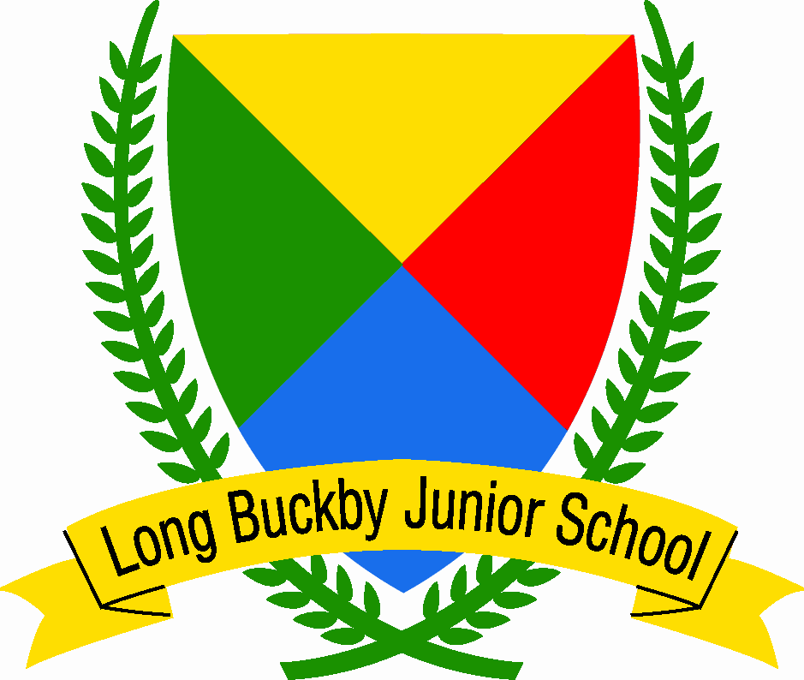

Long Buckby Junior School SEND Policy and Information Report 2025-2026
Welcome to our Special Educational Needs (SEN) information report, which is part of the West Northamptonshire Local Offer for learners with special educational needs and disability.
With 182 children currently on roll, Long Buckby Junior School has a 9% SEND population. Our percentage of children receiving SEND support stands at 8% and we have 3% of our children with an Education, Health and Care Plan (EHCP). The national averages for SEN support and EHCP are 13.6% and 4.8% respectively (Department for Education, 2024).
The Special Educational Needs Code of Practice (2014: para xii-xiv) defines SEN as follows:
“A child or young person has SEND if they have a learning difficulty or a disability which calls for special education provision to be made for him or her. A child of compulsory school age or a young person has a learning difficulty if he or she:
- has a significantly greater difficulty in learning than the majority of others the same age, or
- has a disability which prevents or hinders him or her from making use of facilities of a kind generally provided for others of the same age in mainstream schools or mainstream post-16s institutions.”
In addition, the Code of Practice (2014: para 1.24) states that ‘high quality teaching that is differentiated and personalised will meet the individual needs of the majority of children and young people. Some children and young people need educational provision that is additional to or different from this. This is special educational provision under Section 21 of the Children and Families Act 2014.’
Our latest Ofsted report of 2023 concluded that ‘Pupils with SEND are well supported in lessons. Teachers use a range of adaptations to make learning accessible for these pupils. The school works effectively with external agencies to ensure that pupils’ needs are met.’
If you have any concerns regarding your child’s progress or well-being, then please speak to your child’s class teacher in the first instance.
The kind of Special Educational Needs which are provided for at our school
The SEN Code of Practice (2015) identifies four broad areas of need:
- Communication and Interaction
- Cognition and Learning
- Social, Emotional and Mental Health Difficulties
- Sensory and/or Physical Needs.
Long Buckby Junior School has had success in providing for a wide range of children who are identified in one or more of the broad areas of need, including children with:

- Dyslexia
- Dyspraxia
- Social, Emotional and Mental Health Difficulties,
- Autism and Autistic Tendencies
- Physical disability
- Visual impairment
- Hearing impairment

Admissions

In admitting pupils with special educational needs and disabilities we would expect to have informative discussions with both the pupil’s family and the local authority to ascertain the suitability of our provision. WE understand that it is initially our responsibility to make provision for a pupil with special educational needs and disabilities through the school’s devolved SEND budget. However, as a mainstream school, it would clearly be difficult for us to make provision for pupils whose needs and/or demands are significant, severe or profound – to the extent that it could be argued that they would be most appropriately placed in a specialist provision. When making this judgement we take into consideration:
- The WNC Ranges document,
- If the school is unsuitable for the child’s or young person’s age, ability, aptitude or special educational needs, or
- If the placement would be incompatible with the efficient education of others with whom the child or young person would be educated, or with the efficient use of resources.
Policies for identifying children and young people with SEN and assessing their needs
The SENDCo role at Long Buckby Junior School is performed by Mrs Jenny Bees. Mrs Bees can be emailed at senco@longbuckby-jun.northants-ecl.gov.uk, or phoned on 01327 842445. She will be on maternity leave until June 2026 and so Mr Tony Cox will be the named SENDCo in her absence – head@longbuckby-jun.northants-ecl.gov.uk
West Northamptonshire Council (WNC) stipulate the SEND Ranges as the mandatory framework for the Graduated Approach to SEND. This includes assessment and planning, teaching and learning, interventions, training and resources. The WNC SEND Ranges is accessible on the Local Offer, which can be found linked on our school website. The WNC SEND Ranges standardise the excellent SEN provision across mainstream and specialist EYFS, Primary, Secondary and Post 16 educational settings.
A clear intervention pathway is in place at Long Buckby Junior School, in line with the WNC SEND Ranges, ensuring the appropriate level of support required by an individual child is provided.

The following initiatives outline the robust identification and assessment procedures Long Buckby Junior School has in place:
Prior to children joining the school at the beginning of Year 3, the SENDCo has a meeting with the SENDCo from the Infant School (or alternative feeder school) to discuss the needs of any children with identified SEN, or indeed children who require monitoring. This ensures early awareness of required provision and a continuation of support, in line with the WNC SEND Ranges.

The SENDCo completes an initial audit of need at the start of a new academic year. There is a termly audit of special educational need across the entire school. This ensures that current provision remains effective.

There are high expectations of teaching staff, to ensure that all children receive appropriate and timely initial and ongoing school-based assessments specific to their individual need. Prompt discussions are held with parents and staff where concerns are expressed which lead to further investigation.

Where required, there will be multi-professional working with agencies such as Educational Psychology, Community Paediatricians, Occupational Therapy and Physiotherapy in order to commission specific assessments for identification of need. Mr Cox, as well as Mrs Eltherington, are lead practitioners for Early Help Assessments.
Arrangements for consulting parents of children with SEN and involving them in their child’s education
The school strives to work in partnership with parents and carers. The involvement of parents/carers begins upon the expression of a potential special educational need. Information gathering from both home and school forms part of the initial and indeed ongoing assessment process.
If a child needs to be referred to an outside agency, parents will be asked for their permission and views, which form part of the referral process. When a child has a Learning Plan the parents/carers are part of the consultation review process. Children with Education, Health and Care Plans will receive an Annual Review, alongside termly Learning Plan reviews. Parents/carers will be kept up to date in relation to interventions and progression by their child’s class teacher and/or the SENDCo.
Arrangements for consulting young people with SEN and involving them in their education
All children on the school’s SEND register will have a Pupil Profile. The Profile is completed by the child, with the support of an adult. It allows the child to express their views on their strengths, areas of development and how they wish to be supported at school. This document will ensure awareness and consistency of support across classes and in instances of cover staff.
The children are constantly involved in discussion whilst their SEN intervention programmes are happening. For children with a Learning Plan, their views are sought during the writing and review parts. Pupil interviews to gain the young person’s views is part of the SENDCo’s and wider school’s monitoring cycle.

Arrangements for assessing and reviewing children and young people’s progress towards outcomes
Long Buckby Junior School uses standardised assessments in order to thoroughly track the progress of students. A small steps tracking system is in place for children with SEND as necessary.
Children’s needs are identified and met as soon as possible through:
- Analysis of Key Stage 1 data and standardised baseline data collected at the beginning of each academic year.
- Consultation with parents/carers
- Discussion with the pupil to gain their views
- Information from previous schools and other agencies.
- Individual and targeted assessments, for example the Salford Reading Test, Phonics Assessment and the Vernon Spelling Test.
- Maintaining a detailed provision map for all children with SEND
- Termly review of Learning Plans
- Annual review of Education, Health and Care Plans
- Higher Needs Funding
Evaluating the effectiveness of the provision made for children and young people with SEND.
Long Buckby Junior School undertakes careful monitoring of the impact of the effectiveness of the SEND provision, just as it does for all areas of the school. The format of this monitoring is through the Assess, Plan, Do, Review Cycle. The primary provision for SEND children, as for all children, is quality first teaching. The effectiveness of this is evaluated within the senior leadership monitoring cycle for the school.
For those children with SEND, data analysis is drawn from both standardised, age appropriate assessment scores and, where appropriate, small steps progression using small step targets. Children with SEND who receive either group or 1:1 intervention will also be monitored closely through observation, work scrutiny and discussions with staff, parents and the child.
Termly audits of special educational need capture the requirements of the entire SEND population and ensure that provision is appropriately tailored. SEND intervention staff work across the school, specialising in specific 1:1 and/or group interventions. Learning Walks, focusing upon in-class provision and the implementation of SEND interventions take place across the year. Findings are reported back to the Senior Leadership Team and SEND Governor. Learning Plan reviews take place on a termly basis, or where required, are updated as necessary. Such reviews are held by the class teacher, in conjunction with the SENDCo, with parents/carers and any other agencies invited.
The approach to teaching children and young people with SEN
Embracing inclusion, the school endeavours to teach all children together in their classes, where possible, with the class teacher differentiating and supporting the child. All children will have access to quality first teaching.
When it is deemed necessary, a child with SEND will be withdrawn at specific times for an intervention; either 1:1 or as part of a group. Some children with SEND may have funded 1:1 or small group support within class. Specially adapted resources are used where appropriate, in order to enhance a child’s access to learning. Peer talk is encouraged in every lesson, across the learning need spectrum.
For some children, the school utilises the expertise of outside support agencies.
How adaptations are made to the curriculum and the learning environment
Using monitoring data, the SENDCo, class teacher and 1:1 support assistant plan the provision for all core and non-core subjects in order to tailor teaching and learning for children with Education, Health and Care Plans who are working significantly below their chronological age (2+ years).
Within class, teachers adapt the curriculum and elements of the learning environment, in order to meet the needs of children with SEND. Designated work stations, classroom positioning and space for additional resources are all facilitated.

The expertise and training of staff
Both the SENDCo, Mrs Bees, and Mr Cox have completed the Post Graduate Certificate in Special Educational Needs Co-ordination.
Teachers and support staff have received training in:
- Attachment Awareness
- Emotions Coaching
- Dyslexia Awareness
- Autism Awareness
Specific staff have received training in
- Emotional Literacy Support (ELSA)
- Protective Behaviours
- Early Reading
- Precision Teaching
- Lego Therapy
- Drawing and Talking
All teachers are trained to implement an assessment of dyslexic traits. Specific support staff have received training in Reading Recovery, Numicon and a range of different other intervention programmes. They also attend in-service training provided by outside agencies when appropriate.
Where specialist expertise is not present within the school, partnership working with Educational Psychologists, School Nurse, Occupational Therapists, Speech, Language and Communication, Teacher of the Deaf, schools with specialist provisions and a plethora of other needs specific services are part of the school’s commitment to develop each and every child to the very best of their potential.
Due to our wide range of staff expertise, we are able to provide the following provisions:
- Reading Recovery Approaches – The programme is different for every child, starting from what the child knows and what he/she needs to learn next. The focus of each lesson is to comprehend messages in reading and construct messages in writing, learning how to attend to detail without losing focus on meaning.
- Precision Teaching – this is an intensive intervention used to help children who struggle with reading and/or spelling make accelerated progress. Every child taking part in Precision Teaching sessions receives 10 minutes 1:1 with a Teaching Assistant on a focused sound which they repeat until it is mastered.
- Dyslexic traits intervention – Dyslexia Gold is an intervention for children assessed as displaying significant traits of dyslexia.
- Numicon – a visual and kinaesthetic way of teaching mathematics that can be used in small groups or as a whole class.
- Emotions Coaching – this is a whole school approach, encompassing steps to recognise, validate and label emotions. Such an approach provides the ability to teach children to problem solve in relation to their own emotions and actions.
- Lego Therapy – this is an intervention which supports children, using their love of play, to develop their communication and social skills. Children will work in small groups of three and have their own individual role in collaboratively building a Lego model.
- Drawing and Talking – these are 1:1 sessions which focus on supporting a child to process their emotions or trauma they may be experiencing. They will draw what they choose and be encouraged to talk about their thoughts and feelings to help them make sense of their internal world. These sessions will take place once a week over 12 sessions.
How children and young people with SEND are able to engage in activities available with children and young people in the school who do not have SEND
As an inclusive school, we strive to ensure that pupils of all needs and abilities are fully integrated and included in school life. Wherever possible, we make supportive curriculum adaptations within class, as opposed to withdrawing a child. Lessons are differentiated appropriately, following the responsibility model, providing opportunities for group, pair and independent work. Additional staff are deployed, where appropriate, to ensure inclusive learning, whether this be within school or outside of school, for example, on school trips.

Support for improving emotional and social development
In lower Key Stage 2, a daily ‘check in,’ of emotions is used with all children, in order to develop the language of emotional literacy. In addition, the use of emotion cards, ‘help’ cards, Worry Eaters and Tangles Toys (to assist with anxiety) are used on an individual need basis.
Through the use of Emotion Coaching, all staff are accountable for the emotional and social development of children. As a school, we follow the Department for Education’s recommendations on Relationships, Sex and Health Education through the scheme SCARF.
How the school involves other bodies, including health and social care bodies, local authority support services and voluntary sector organisations
Our school will identify sources of support as they develop and evolve according to the provisions of the Local Offer. We have experience of working with the following agencies:
- Educational Psychologist Team
- CAMHs (Child and Adolescent Mental Health)
- School Nurse
- Community Paediatricians
- Teacher of the Deaf
- Behaviour support services
- Specialist Support Service
- Speech, Language and Communication Therapists
- Occupational Therapists
- Augmentative and Alternative Communication Service
- Visual Impairment Service
- Physiotherapists
- Bereavement Counsellors
- Early Help Team
- Sleep Solutions
- School Attendance Support Service
- Information Advice Support Service
The school uses The Early Help Assessment (EHA) process to access support from other agencies if necessary. Mr Cox and Mrs Eltherington have been trained on how to run and manage an EHA and Team around the Family.
External agency professionals are routinely invited to attend Early Help, Learning Plan and Education, Health and Care Plan reviews.
Information about how equipment and facilities to support children and young people with special educational needs will be secured
The school allocates money from its budget every year towards the provision of support for SEN. These funds are used to provide support, resources and training for staff.
When specialist equipment or a high level of staffing support is required to support a pupil with special educational needs, our school will fund this as additional SEND support up to £6,000 per annum for each individual pupil. Thereafter, if the cost is higher and the provision of these facilities is likely to be prolonged, the school will apply to the Local Authority for extra funding.
Where appropriate, specialist equipment will be sourced and loaned from the appropriate services, for example, other schools or the Alternative and Augmentative Communication Service.
Arrangements for supporting children and young people in moving between phases of education
The school works hard on ensuring that there is a smooth transition both for the children joining the school and for those transferring to Secondary School. Meetings with feeder infant/primary and receiving secondary school SENCOs are held, where each child is discussed in detail and necessary information is passed on.
For the children joining the school at the beginning of Year 3, opportunities are provided for the whole cohort to spend extra days at the school on top of the official induction days. Similar opportunities are provided by the feeder secondary school.
Arrangements for handing complaints from parents of children with SEN about the provision made at the school
The school’s complaints policy is available on the website http://www.longbuckbyjunior.co.uk/school-information/policies for parents to view.

Useful Contact Details
The web address for the local authority is shown below and this is a useful site to gain further information.
https://www.northamptonshire.gov.uk/councilservices/children-families-education/send/local-offer/Pages/default.aspx
The Northamptonshire’s Information Advice Support Service (IASS) is another useful website for parents/carers:
http://www.iassnorthants.co.uk/Pages/home.aspx
Information on where the local authority’s Offer Local Offer is published
Details on this can be found at:
https://www3.northamptonshire.gov.uk/councilservices/children-families-education/send/local-offer/Pages/default.aspx

References
Department for Education (2024) ‘Special Educational Needs in England’ Special educational needs in England, Academic year 2023/24 - Explore education statistics - GOV.UK (explore-education-statistics.service.gov.uk) (accessed 4th September 2024).

Department for Education and Department of Health (2014) ‘The Special Educational Needs and Disability Code of Practice: 0-25 years.’ https://assets.publishing.service.gov.uk/government/uploads/system/uploads/attachment_data/file/398815/SEND_Code_of_Practice_January_2015.pdf (accessed 4th September 2024).

